

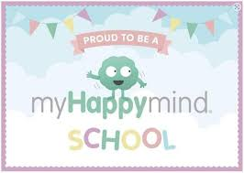

Dear Parents,
We introduced this program to all year groups at Old Bexley in February 2025. myHappymind is based around helping children to understand how their brain works and to support them in developing positive skills and habits to be their very best selves!
myHappymind is delivered in schools by class teachers through a series of interactive lessons and then the children apply these learnings throughout the day.
To further embed this learning, myHappymind has developed a Parent App. These resources can be accessed online on your computer, or through an app on your phone. The Parent App will support you as a parent in understanding what your child is learning, activities for you to do together at home and also a Kids Zone featuring myHappymind Games plus much more!
I know a lot of parents have downloaded the app and are using it at home to support their children. This is a reminder for you to download it if you have not already done so. There are new resources available as well.
To access these materials just go to https://myhappymind.org/parent-resources to create your free account. You will need to enter your name, email, and authentication code.
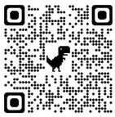
Your authentication code is 142228 OR simply scan this QR code to sign up

Once you have created your account, you will receive an email with the next steps on downloading the app.
We really encourage you to make use of this free content so that you can support your child in getting the best out of the curriculum.
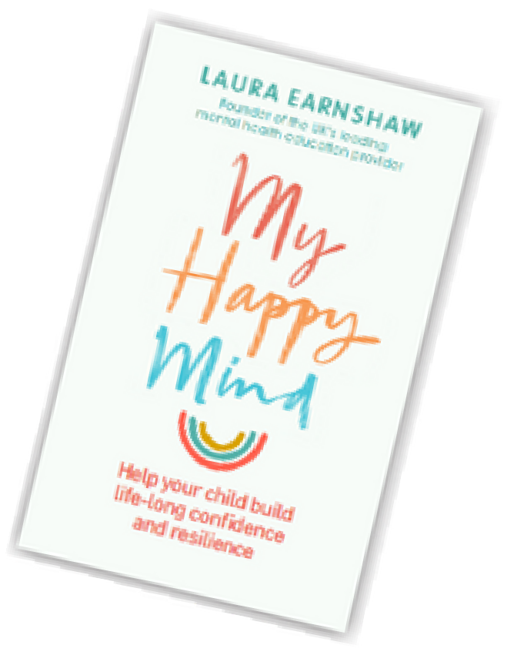
If you have any questions about myHappymind, please contact your class teacher.
If you have any technical questions about accessing the resources, please contact hello@myHappymind.org
Want to learn more? Check out myHappymind founder Laura Earnshaw’s best selling book on Amazon. We also have copies in school if you would like to borrow it
Many thanks,
Mrs Jill Ivil

